SRM 611 – Advanced Statistical Data Analysis
Project 3: Count and Proportion Models
Weekend Alcohol Use and School Absences: A Poisson and Negative Binomial Analysis
Fred Chen
University of Northern Colorado
October 2026

Part I
Proportion Data
A proportion can arise in two ways. In the first, the analyst observes a known number of events $y_{i}$ out of a known number of trials $n_{i}$, e.g. 7 successes in 20 attempts. The ratios $y_{i}/n_{i}$ then summarize binary outcomes and the natural model is binomial:
$$y_{i}∼\text{Binomial}\left(n_{i},π_{i}\right), \text{logit}\left(π_{i}\right)=x_{i}^{⊤}β$$
Since $n_{i}$ is known, the variance $n_{i}π_{i}\left(1-π_{i}\right)$ is fixed by the model and observations with more trials automatically count more.
In the second case, the proportion is a summary measure where the underlying number of trials is not known, undefined or not meaningful. Examples include a county poverty rate based on a survey estimate, the share of a budget devoted to a particular category, or a graduation rate published without the size of the cohort. The response is then just a real number $y_{i}∈\left(0,1\right)$. You can’t use a binomial model because there is no $n_{i}$ to give. Ordinary linear regression is also not a good choice: it can predict values outside $\left(0,1\right)$, and it assumes constant variance, whereas the variance of a bounded proportion decreases near 0 and 1. For this case we use Beta regression:
$$y_{i}∼\text{Beta}\left(μ_{i}ϕ,\left(1-μ_{i}\right)ϕ\right), \text{logit}\left(μ_{i}\right)=x_{i}^{⊤}β, \text{Var}\left(y_{i}\right)=\frac{μ_{i}\left(1-μ_{i}\right)}{1+ϕ}$$
The distinction is what makes the model. If the events are out of known trials, then use binomial (logistic) regression; if you only have summary proportions and no trials then use Beta regression. The Beta distribution is only defined on the open interval, so values of exactly 0 or 1 must be adjusted, often using $y^{*}=\left[y\left(n-1\right)+0.5\right]/n$.

Count Data
A count response is the number of times that an event occurs for each unit in a fixed time or area. For example, the number of absences during a school year. Counts are non-negative integers. They are often right skewed with many small values and a long upper tail. They often have many zeros. Their variance usually increases with the mean.
There are often four reasons why a normal linear regression model is not appropriate:
- It can give negative fitted values, which is impossible for counts.
- It assumes constant variance, while the variance of counts generally increases with the mean.
- It assumes that the errors are normally distributed which is not true for discrete skewed data especially when the mean is small.
- This assumes effects of predictors are additive on the count scale, whereas effects on counts are usually multiplicative.
Poisson count regression models the log of expected count:
$$Y_{i}∼\text{Poisson}\left(μ_{i}\right), \log\left(μ_{i}\right)=β_{0}+β_{1}x_{i1}+⋯+β_{p}x_{ip}, E\left(Y_{i}\right)=\text{Var}\left(Y_{i}\right)=μ_{i}$$
The quantity being modeled is the mean count $μ_{i}=E\left(Y_{i}∣x_{i}\right)$, or a rate if an offset $\log\left(t_{i}\right)$ for exposure time is included. The fitted means are always positive with the log link. The interpretation of each coefficient is multiplicative: $e^{β_{j}}$ is the incidence rate ratio (IRR), the multiplicative change in the expected count for a one unit increase in $x_{j}$, with the other predictors held constant.

Overdispersion
The Poisson model assumes that the variance equals the mean. Overdispersion occurs when the observed variability is greater than that, $\text{Var}\left(Y_{i}\right)>μ_{i}$. Common reasons are unmeasured differences between units, clustering, positive correlation among events, and excess zeros.
Four methods can be used to detect overdispersion.
- Descriptively: Contrast sample variance and sample mean, overall and within predictor groups.
- From the fitted model: calculate $\overset{ˆ}{ϕ}=X^{2}/\left(n-p\right)$ and $D/\left(n-p\right)$, where $X^{2}$ is the Pearson chi-square and $D$ is the residual deviance. Values close to 1 are consistent with the Poisson assumption, while values much above 1 indicate overdispersion.
- With formal tests: the Cameron-Trivedi test of $H_{0}:α=0$ versus $\text{Var}\left(Y_{i}\right)=μ_{i}+αμ_{i}^{2}$, or a likelihood ratio test comparing the Poisson and negative binomial fits.
- Graphically: Compare the observed count frequencies to those predicted by the Poisson model, especially the number of zeros.
The presence of overdispersion does not usually bias the Poisson coefficient estimates but it does cause the model to understate their standard errors. Confidence intervals can be too tight, and p-values can be too small to make predictors look significant when they’re not. The Poisson model also does not fit the shape of the distribution well, underestimating both zeros and large counts.
Where overdispersion is relevant, the usual alternative is negative binomial (NB2) regression. It has the same log-linear mean, but with an added dispersion parameter:
$$\text{Var}\left(Y_{i}\right)=μ_{i}+αμ_{i}^{2}=μ_{i}+\frac{μ_{i}^{2}}{θ}$$
The model reduces to the Poisson as $α→0$.
Model Selection and Interpretation
Model | Response | Distribution | Link | Variance
Beta | Continuous proportion in (0,1), no trials | Beta | logit | μ(1 − μ)/(1 + φ)
Poisson | Count 0, 1, 2, … | Poisson | log | μ
Negative binomial | Count 0, 1, 2, … | Negative binomial | log | μ + αμ²
Table 1: Model Comparison
Beta regression is for a bounded continuous rate or percentage that is not a count of events out of known trials. Its coefficients are on the log-odds scale and $e^{β_{j}}$ multiplies the odds $μ/\left(1-μ\right)$. Poisson regression is the natural starting point for counts and is appropriate when the conditional variance is close to the mean. Negative binomial regression is for counts with variance larger than mean. Both count models are interpreted by IRRs, $e^{β_{j}}.$
The choice depends on the structure and distribution of the response. First decide if the response is a count or a proportion. For a proportion, ask if events and trials are known: if so, a binomial model is used; if not, Beta regression. For a count, fit the Poisson first, then check the variance relative to the mean, the dispersion statistics and the fit to the observed frequencies. If overdispersion is relevant, choose the negative binomial model. Confirm this choice with a likelihood ratio test of $α=0$ and an AIC comparison.

Part II
Purpose of the Analysis
Absences from school are linked to lower grades and an increased risk of dropping out. It is therefore helpful to know what student characteristics are linked to more absences.
In this analysis we ask whether students who drink more alcohol on weekends are also more likely to miss school, controlling for other characteristics that may also affect attendance.
Research question: Is weekend alcohol consumption associated with the number of school absences among secondary school students, adjusted for study time, past class failures, sex, age and school?
Response: number of absences from school during the school year “absences”
Primary predictor: weekend alcohol consumption “Walc”, self-rated from 1 (very low) to 5 (very high)
Control Variables: weekly study time “studytime”, number of past class failures “failures”, sex, age and school attended “school”
Population: students attending a Portuguese language course in two public secondary schools in Portugal, school year 2005–2006
Description, Source, and Exploration of the Data
The data are from the Student Performance data set, distributed by the UCI Machine Learning Repository. It was downloaded from Kaggle, where it was posted by the UCI Machine Learning as the “Student Alcohol Consumption” data set. Data were gathered from school reports and student questionnaires in two schools, Gabriel Pereira (GP) and Mousinho da Silveira (MS). The data are publicly available and contain no identifying information.
The data set contains two files: a mathematics course (395 students) and a Portuguese course (649 students). There are about 382 students who appear in both. Therefore, to consider each student as one independent observation, only the larger Portuguese file “student-por.csv” was analyzed.
The unit of observation is a student. The data file contains 649 students and 33 variables with no missing values. The variables used are listed in Table 2:
Variable | Role | Type | Coding
absences | Response | Count | 0–32 in this sample
Walc | Primary predictor | Ordinal, treated as numeric | 1 = very low to 5 = very high
studytime | Control | Ordinal, treated as numeric | 1 = <2 h, 2 = 2–5 h, 3 = 5–10 h, 4 = >10 h per week
failures | Control | Count | 0–3 (3 = three or more)
sex | Control | Binary | F (reference), M
age | Control | Numeric | 15–22 years
school | Control | Binary | GP (reference), MS
Table 2: Variables Used
The sample consists of 383 female and 266 male students. 423 students attended GP and 226 attended MS. Age range was 15–22 (mean 16.74 years). Most students reported studying low amount of time (212 students reported studying less than 2 hours a week and 305 students reported studying between 2 and 5 hours a week) and most students had no previous failures (549 out of 649 students).
Weekday alcohol use “Dalc” was excluded for two reasons: it's strongly correlated with weekend use ($r=0.62$) and concentrated at the lowest level (451 of 649 students), so adds little separate information.
The response: Absences ranged from 0 to 32 with a mean of 3.66 and a median of 2. The distribution is highly skewed to the right (see Figure 1). 244 students (37.6%) had no absences, but a few had 20 or more. The variance is nearly six times the mean, an early warning that the Poisson assumption $\text{Var}\left(Y\right)=E\left(Y\right)$ will not be satisfied:
$$\overline{y}=3.66, s^{2}=21.54, s^{2}/\overline{y}=5.89$$
As can be seen from Figure 1, even values are also much more frequent than odd ones. For example, 110 students had 2 absences but only 12 had 1, and 93 students had 4 absences but only 7 students had 3. This heaping suggests absences were often recorded in blocks of two, reflecting how they were counted, not student behavior.
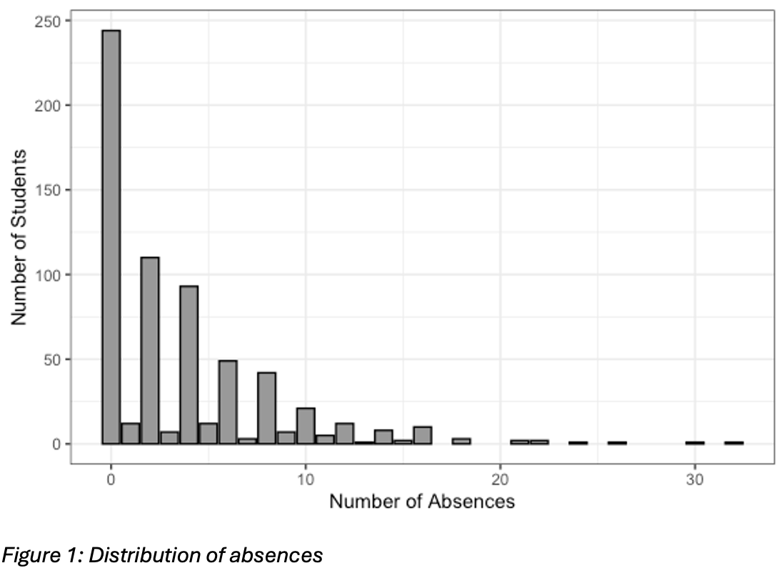
Absences and weekend alcohol use: Weekend drinking is associated with higher average absenteeism, varying from 2.89 at level 1 to 5.24 at level 5 (Figure 2). The variance within each level is 4.6 to 7.7 times the mean, so the extra variation is not just due to variation between alcohol groups. Most students say they drink little on weekends (247 at level 1, only 45 at level 5).
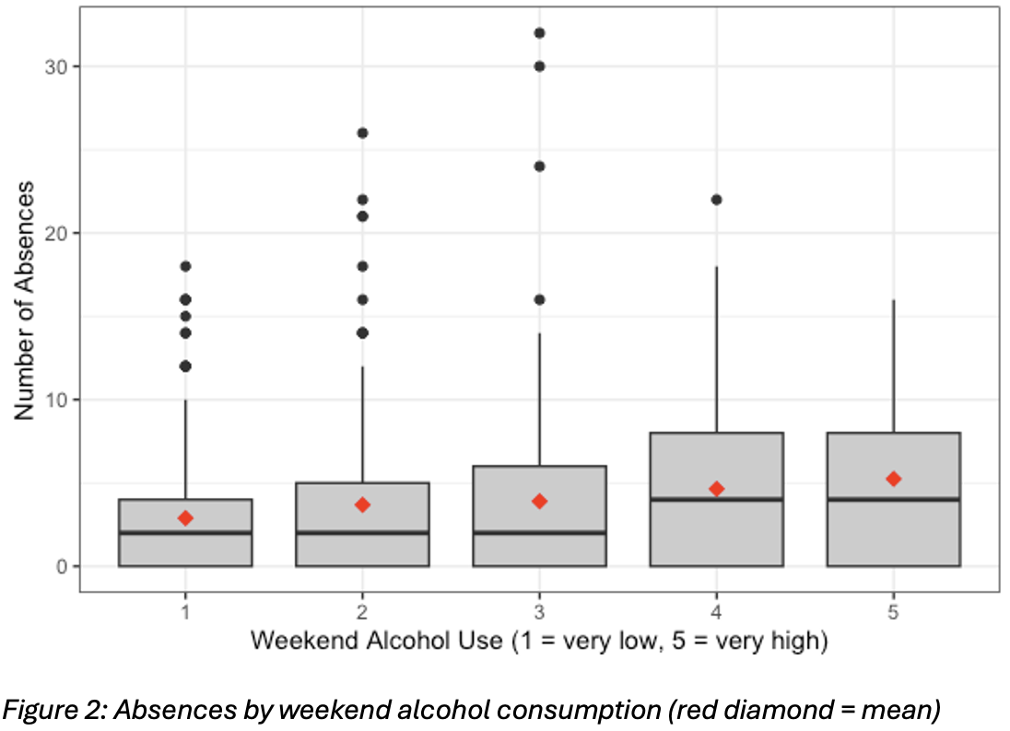
Proposed Analysis
Absences are counts of non-negative integers with a skewed distribution. The analysis is thus based on count regression with a log link. First, we fit a Poisson model:
$$Y_{i}∼\text{Poisson}\left(μ_{i}\right)$$
$$\log\left(μ_{i}\right)=β_{0}+β_{1}{\text{Walc}}_{i}+β_{2}{\text{studytime}}_{i}+β_{3}{\text{failures}}_{i}+β_{4}{\text{Male}}_{i}+β_{5}{\text{age}}_{i}+β_{6}{\text{MS}}_{i}$$
All students were followed during the same school year, so no offset of exposure was needed. The exploratory evidence ($s^{2}/\overline{y}≈5.9$) would suggest the need for a negative binomial (NB2) model with the same linear predictor:
$$Y_{i}∼\text{NB}\left(μ_{i},θ\right), \text{Var}\left(Y_{i}\right)=μ_{i}+\frac{μ_{i}^{2}}{θ}=μ_{i}+αμ_{i}^{2}$$
The two models are compared using the dispersion statistics, a likelihood ratio test of $H_{0}:α=0$, AIC and BIC and how well each reproduces the observed distribution of absences.
The predictors were selected as follows:
The research question is answered by “Walc”. It is entered as a single numeric term, therefore $e^{β_{1}}$ is the change in expected absences for each one level increase in weekend drinking. This linear trend is compared with a model with a separate effect for each level.
“studytime” and “failures” are measures of academic involvement. Students who study less or have failed before may also skip more school, and both are plausibly related to drinking.
“sex” and “age” are common demographic controls. Older students in secondary school are often students that have been held back a grade.
The two schools differ in attendance policy, record keeping, and student population. “School” accounts for differences.
Analysis Results
Poisson Model and Overdispersion
The Poisson model is severely over dispersed. Both dispersion statistics are close to five times their degrees of freedom:
$$\frac{D}{n-p}=\frac{3103.24}{642}=4.83, \overset{ˆ}{ϕ}=\frac{X^{2}}{n-p}=\frac{3163.02}{642}=4.93$$
If the Poisson assumption were true, values close to 1 would be expected. The Cameron-Trivedi test regresses $\left[{\left(y_{i}-{\overset{ˆ}{μ}}_{i}\right)}^{2}-y_{i}\right]/{\overset{ˆ}{μ}}_{i}$ on ${\overset{ˆ}{μ}}_{i}$ without intercept. It yields $\overset{ˆ}{α}=1.00$ ($SE=0.10$, $t=9.80$, $p<.001$), rejecting $H_{0}:α=0$.
This means that the Poisson standard errors are too small by a factor of about $\sqrt{4.93}≈2.2$ in practice. Under the Poisson model, all the six predictors seem to be quite significant ($p<.001$), but the p-values are not quite reliable.
Negative Binomial Model and Comparison
The negative binomial model gave $\overset{ˆ}{θ}=0.625$ ($SE=0.050$), so $\overset{ˆ}{α}=1/\overset{ˆ}{θ}=1.60$. The implied variance for a student with the average expected count is close to the observed variance of 21.54:
$$\text{Var}\left(Y\right)=3.66+1.60{\left(3.66\right)}^{2}≈25.1,$$
The Poisson model would show only 3.66.
The negative binomial model was preferred in all comparisons:
Likelihood ratio test: $LR=2\left(l_{\text{NB}}-l_{P}\right)=2\left(-1517.19+2238.19\right)=1441.99$. Because $α=0$ is on the boundary of the parameter space, $p=\frac{1}{2}P\left(χ_{1}^{2}>1441.99\right)<.001$.
AIC and BIC: AIC falls from 4490.38 to 3050.38 and BIC from 4521.70 to 3086.19. This is a reduction of about 1440 for one additional parameter.
Pearson $X^{2}/df$: drops from 4.93 to 0.74, so the remaining variation is consistent with the NB variance function
Fit to the distribution (Figure 3). The Poisson curve is centered around the mean and misses both the spike at zero and the long right tail badly. It predicts only about 5% of students with zero absences, compared to 37.6% observed. The negative binomial curve fits the overall shape and predicts about 32% zeros. The even–odd pattern, due to the way absences were recorded, cannot be reproduced by either model.
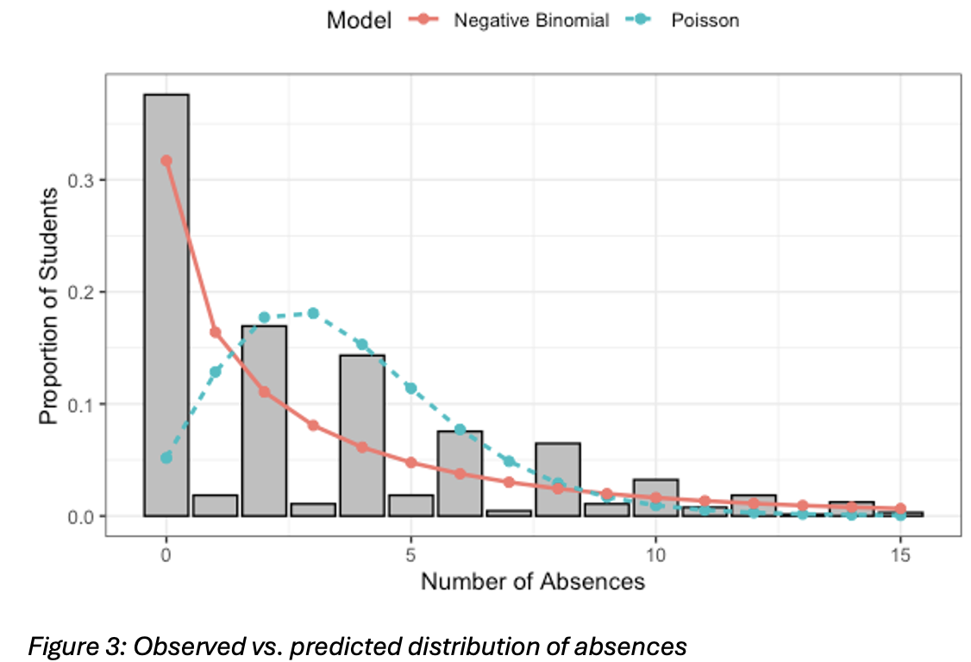
The choice of model matters. The coefficient estimates are roughly similar under the two models, but the negative binomial standard errors are 2.4 to 3.1 times larger and two conclusions change (Table 3):
Predictor | Poisson p | NB p
sex (M) | < .001 | .149
failures | < .001 | .056
Table 3: Poisson p vs. NB p for sex and failures
Alcohol use on the weekend, study time, age and school are significant for both models.
Model Checks
Linearity of Walc: Compared the linear Walc term to a model with a separate effect for each level. The test yields $LR=0.37$ on 3 df ($p=.947$), indicating that one multiplicative effect per level fits the data as well as the more flexible model.
Residuals: The Pearson residuals are near zero against the fitted values, and the smoothed trend is approximately flat (Figure 4). The diagonal bands are typical for count data. Each band is one observed value. The lowest band is students with zero absences. The slight dip on the far right is based on only a handful of students.
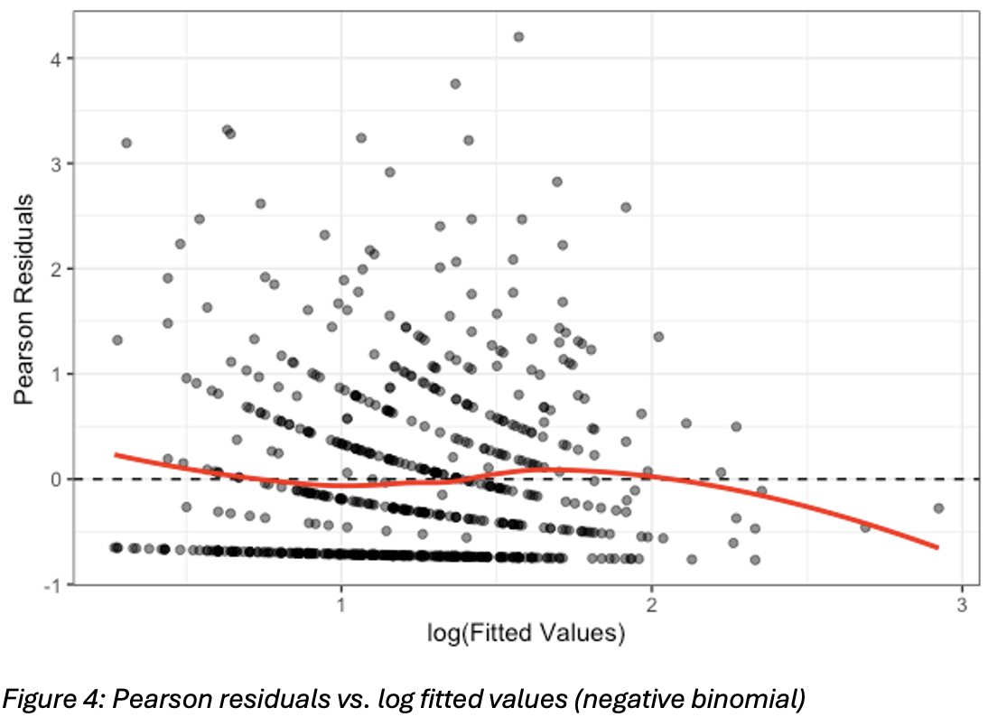
Influence: twenty students (3.1%) surpass the Cook's distance screening value $4/n=0.0062$. The largest value is only 0.034 so no individual student is driving the results and no observations were dropped.
Final Model
$$\log\left({\overset{ˆ}{μ}}_{i}\right)=-0.292+0.152 {\text{Walc}}_{i}-0.162 {\text{studytime}}_{i}+0.183 {\text{failures}}_{i}-0.172 {\text{Male}}_{i}+0.102 {\text{age}}_{i}-0.563 {\text{MS}}_{i}, \overset{ˆ}{θ}=0.625$$
Below is the interpretation of incidence rate ratios (IRRs) from the final model (holding the other predictors constant):
Weekend alcohol use: $\text{IRR}=e^{0.152}=1.16$ (95% CI 1.07–1.27, $p<.001$). Each additional level of weekend drinking was associated with about a 16% increase in expected absences. From the lowest level to the highest level, $e^{4\left(0.152\right)}=1.83$, about 83% more absences.
Study time: IRR=0.85 (0.74–0.98, p=.020). For each step in the study time category, there are about 15% fewer absences.
Past failures: $\text{IRR}=1.20$ (1.00 to 1.45, $p=.056$). With each extra failure there are about 20% more absences, but the evidence is marginal.
Sex: $\text{IRR}=0.84$ (0.67–1.06, $p=.149$). No clear difference between male and female students.
Age: $\text{IRR}=1.11$ (1.01–1.22, $p=.031$). Each additional year of age was associated with about 11% more absences.
School: $\text{IRR}=0.57$ ($p<.001$, 95% CI = 0.45-0.72). MS students have experienced about 43% fewer absences than comparable GP students. This could be due to differences in attendance or differences in reporting absences.
Conclusions
Students who drink more alcohol on the weekends tend to skip more school, even after controlling for how much they study, whether they’ve failed classes in the past, their sex, their age and what school they go to. Each point increase on the five-point scale for weekend drinking is linked to about 16% more absences. At the top, students are expected to miss about 80% more school than comparable students at the bottom. Students who study more tend to miss less school, older students tend to miss more, and recorded absences are considerably less at one of the two schools.
The model proposed is the negative binomial regression. Absences are counts, so a count model is the right type of model. But the standard Poisson model assumes the spread of counts equals their mean, and here the spread is about five times larger. Thus, the Poisson model under-predicts the number of students with zero absences, and makes its results seem more certain than they are; it would have falsely indicated strong effects of sex and past failures. The negative binomial model does allow for the extra variation, fits the data far better on every measure and gives more honest measures of uncertainty.
The most important limitation is that the data are observational, and alcohol use is self-reported. The results show an association, not that drinking causes absences. Other factors such as health, family circumstances or general engagement with school, could influence both drinking and attendance, and students may under-report their drinking.

References:
UCI Machine Learning. Student Alcohol Consumption [Data set]. Kaggle. https://www.kaggle.com/datasets/uciml/student-alcohol-consumption

Appendix:
---
title: "SRM 611 Project 3: Count and Proportion Models"
author: "Fred Chen"
date: "`r format(Sys.Date(), '%B %Y')`"
output:
word_document: default
---

```{r setup, include=FALSE}
knitr::opts_chunk$set(echo = TRUE, message = FALSE, warning = FALSE,
fig.width = 6, fig.height = 4, fig.align = "center")
library(ggplot2)
library(knitr)
```

# Part II: Student Absences Analysis

## 2. Description, Source, and Exploration of the Data

### 2.1 Basic data information

```{r data}
student <- read.csv("/Users/fredchen/Documents/Stuff/SRM 611/Project 3/Student Alcohol Consumption/student-por.csv",
stringsAsFactors = TRUE)

dim(student)
str(student)
colSums(is.na(student))
```

### 2.2 Response: absences

```{r response}
summary(student$absences)

resp_summary <- data.frame(
n = length(student$absences),
Mean = mean(student$absences),
Variance = var(student$absences),
Ratio = var(student$absences) / mean(student$absences),
Pct_Zero = mean(student$absences == 0) * 100
)
kable(resp_summary, digits = 2,
caption = "Summary of the response variable (absences)")

table(student$absences)
```

```{r fig1, fig.cap="Figure 1: Distribution of absences"}
ggplot(student, aes(x = absences)) +
geom_bar(fill = "grey60", color = "black") +
labs(x = "Number of Absences", y = "Number of Students") +
theme_bw()
```

### 2.3 Predictors

```{r predictors}
walc_tab <- do.call(rbind, lapply(split(student$absences, student$Walc), function(x)
c(n = length(x), Mean = mean(x), Variance = var(x))))
kable(walc_tab, digits = 2,
caption = "Absences by weekend alcohol use (Walc)")

table(student$Walc)
table(student$Dalc)
table(student$studytime)
table(student$failures)
table(student$sex)
table(student$school)
summary(student$age)
```

```{r fig2, fig.cap="Figure 2: Absences by weekend alcohol consumption (red diamond = mean)"}
ggplot(student, aes(x = factor(Walc), y = absences)) +
geom_boxplot(fill = "grey80") +
stat_summary(fun = mean, geom = "point", shape = 18, size = 3, color = "red") +
labs(x = "Weekend Alcohol Use (1 = very low, 5 = very high)",
y = "Number of Absences") +
theme_bw()
```

```{r collinearity}
# Correlation between weekday and weekend alcohol use
cor(student$Dalc, student$Walc)
```

## 3. Proposed Analyses

```{r model-formula}
library(MASS)

model_formula <- absences ~ Walc + studytime + failures + sex + age + school
```

## 4. Analysis Results

### 4.1 Poisson regression

```{r poisson}
pois_model <- glm(model_formula, family = poisson(link = "log"), data = student)
summary(pois_model)
```

### 4.2 Overdispersion check

```{r dispersion}
pearson_chi2 <- sum(residuals(pois_model, type = "pearson")^2)

disp_tab <- data.frame(
Statistic = c("Deviance", "Pearson Chi-square"),
Value = c(deviance(pois_model), pearson_chi2),
df = df.residual(pois_model),
Ratio = c(deviance(pois_model), pearson_chi2) / df.residual(pois_model)
)
kable(disp_tab, digits = 2, caption = "Poisson goodness-of-fit and dispersion")

mu_hat <- fitted(pois_model)
y <- student$absences
ct_test <- lm(((y - mu_hat)^2 - y) / mu_hat ~ mu_hat - 1)
summary(ct_test)$coefficients
```

### 4.3 Negative binomial regression

```{r negbin}
nb_model <- glm.nb(model_formula, data = student)
summary(nb_model)

c(theta = nb_model$theta, SE_theta = nb_model$SE.theta, alpha = 1 / nb_model$theta)
```

### 4.4 Poisson vs. negative binomial

```{r compare}
lr_stat <- as.numeric(2 * (logLik(nb_model) - logLik(pois_model)))
lr_p <- 0.5 * pchisq(lr_stat, df = 1, lower.tail = FALSE)
c(LR = lr_stat, p_value = lr_p)

fit_tab <- data.frame(
Model = c("Poisson", "Negative Binomial"),
LogLik = c(logLik(pois_model), logLik(nb_model)),
AIC = c(AIC(pois_model), AIC(nb_model)),
BIC = c(BIC(pois_model), BIC(nb_model)),
Pearson_df = c(pearson_chi2 / df.residual(pois_model),
sum(residuals(nb_model, type = "pearson")^2) / df.residual(nb_model))
)
kable(fit_tab, digits = 2, caption = "Model comparison")

se_tab <- data.frame(
Poisson_Est = coef(pois_model),
Poisson_SE = sqrt(diag(vcov(pois_model))),
NB_Est = coef(nb_model),
NB_SE = sqrt(diag(vcov(nb_model)))
)
kable(se_tab, digits = 3, caption = "Coefficient estimates and standard errors")
```

```{r fig3, fig.cap="Figure 3: Observed vs. predicted distribution of absences"}
max_y <- 15
obs_freq <- sapply(0:max_y, function(k) mean(y == k))
pois_freq <- sapply(0:max_y, function(k) mean(dpois(k, fitted(pois_model))))
nb_freq <- sapply(0:max_y, function(k)
mean(dnbinom(k, mu = fitted(nb_model), size = nb_model$theta)))

freq_df <- data.frame(
absences = rep(0:max_y, 3),
proportion = c(obs_freq, pois_freq, nb_freq),
source = rep(c("Observed", "Poisson", "Negative Binomial"), each = max_y + 1)
)

ggplot(freq_df, aes(x = absences, y = proportion)) +
geom_col(data = subset(freq_df, source == "Observed"),
fill = "grey75", color = "black") +
geom_line(data = subset(freq_df, source != "Observed"),
aes(color = source, linetype = source), linewidth = 0.9) +
geom_point(data = subset(freq_df, source != "Observed"),
aes(color = source), size = 1.8) +
labs(x = "Number of Absences", y = "Proportion of Students",
color = "Model", linetype = "Model") +
theme_bw() +
theme(legend.position = "top")
```

### 4.5 Final model: incidence rate ratios

```{r irr}
nb_coef <- summary(nb_model)$coefficients

irr_tab <- data.frame(
Estimate = nb_coef[, 1],
SE = nb_coef[, 2],
IRR = exp(nb_coef[, 1]),
CI_Lower = exp(nb_coef[, 1] - 1.96 * nb_coef[, 2]),
CI_Upper = exp(nb_coef[, 1] + 1.96 * nb_coef[, 2]),
p_value = nb_coef[, 4]
)
kable(irr_tab, digits = 3, caption = "Negative binomial incidence rate ratios")
```

### 4.6 Linearity of Walc

```{r walc-linear}
nb_factor <- glm.nb(absences ~ factor(Walc) + studytime + failures + sex + age + school,
data = student)
anova(nb_model, nb_factor)
```

### 4.7 Diagnostics

```{r fig4, fig.cap="Figure 4: Pearson residuals vs. log fitted values (negative binomial)"}
diag_df <- data.frame(
fitted = fitted(nb_model),
pearson = residuals(nb_model, type = "pearson")
)

ggplot(diag_df, aes(x = log(fitted), y = pearson)) +
geom_point(alpha = 0.5) +
geom_hline(yintercept = 0, linetype = "dashed") +
geom_smooth(se = FALSE, method = "loess", color = "red") +
labs(x = "log(Fitted Values)", y = "Pearson Residuals") +
theme_bw()
```

```{r influence}
cooks <- cooks.distance(nb_model)
sum(cooks > 4 / nrow(student))
head(sort(cooks, decreasing = TRUE))
```

